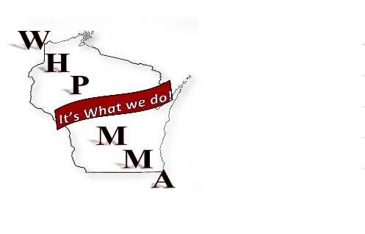
Wisconsin Healthcare Purchasing and Materials Management Association

1/16/2018
WHPMMA Board meeting

Attendees: Deb Bemis, Carol Bland, Leah Shatusky, Joel Roland, Joe Ford, Colin Peterson

Agenda;

Membership Drive;
It was decided to implement the “bring a friend” program to achieve higher membership. If someone brings a friend that hasn’t been to the conference the friend will attend the conference for free, will need to pay for their own hotel room.

Save the Date;
Colin will talk to Peggy on Friday and see if she can send the original of the save the date. I did have a copy of the save the data that we sent out as an e-mail but we are not able to convert it to work on it.

We will add the “bring a friend” and if room put the scholarship information on it as well.

Speakers;
I’ve attached the speakers and their time slots. We only have one more speaker time slot to fill. Before we put the brochure together we will need the topics and summary. I need both to submit for CEU credits.

Brochure;
Once we have the topics and speakers I will put the brochure together. We will have some printed to allow people to hand them out, especial suppliers.

Golf;
Joe is working with Todd Campbell at the golf course to get everything lined up. Thanks Leah for all your work getting this started.
In the past Steve Reidy has provided some hole awards and the WHPMMA put up a couple.
The singer Liz found will perform at the reception following golf.

Website;
We have moved our website to a Wix.com. By doing this we have complete control and can upload and change anything anytime we want. It is also a lot less expensive. Joel set it up but if anyone would like access and help keep it up to date we are happy to accept the assistance.

AHRMM;
We have sent in most of what we need to maintain our charter status. In addition Taxes will be sent in the first part of February to maintain our not-for-profit status. There is a provision that will allow us to opt-out of the full liability insurance but certain requirements will need to be meet.

New Logo;
Should we adopt what was presented?

Location for 2019;
Steve Reidy will pull information together for the Green Bay Area.

In the event Peggy doesn’t have the original Joel has publisher on his computer and can recreate something similar without too much trouble.

If you have any additions, corrections please let me know and I can add them in.

Have a great winter

