Educational…Network… Fun!  Member Registration  Name ___________________________________________  Organization ____________________________________  Phone ___________________________________________  Email ____________________________________________  Friend Name _____________________________________  _________$ 35 Annual Membership Fee (only)  _________$125 Conference  (includes membership fee)  _________$75 Early Bird Registration Fee (expires on August 2nd)  _________ Golf Outing Sept 15th Attendance  Contact Leah Shatusky at Leah.Shatusky@thedacare.org to pay Via PayPal or Mail this form and check to:  WHPMMA  Leah R. Shatusky, Treasurer  506 East Byrd  Appleton WI 54911 |  | Wednesday, September 15th  TBD Golf  TBD Reception  Thursday, September 16th  8:00-8:30 Registration and Continental Breakfast  8:30-9:00 Business Meeting  9:00 - 10:30 Keynote  Joe Delagrave  10:30-11:30 Educational Sponsorship Speaker  11:30 – 1:30 Vendor Fair  1:30 - 2:30 Lunch  2:30 - 3:30 Round Table  3:30 - 4:30 Mike Hopkins  4:30 - 5:30 Girard Senn  6:00 - 9:00 Reception  Friday, September 17th  8:00 - 8:30 Registration and Continental Breakfast  8:30 - 9:30 Dee from AHRMM  9:30 - 10:30 Erik Larson  10:30 - 11:30 Erik Larson  11:30 - 12:30 Educational Sponsor Speaker  12:30-1:30 Election/Closing/Awards  *All speakers subject to change* | WHPMMA 2021Fall Members Conference  September 15-17  Pewaukee WI  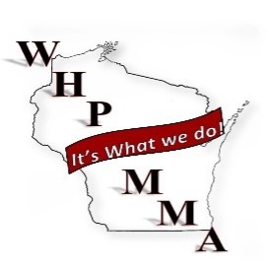
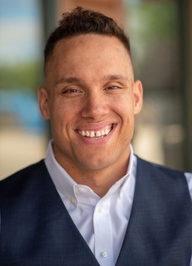  Keynote - Joe Delagrave  Joe Delagrave is a husband, father, elite athlete, and keynote speaker. Joe delivers a powerful message on keys to success no matter what stage of life your in….  - on the ability for us all to find opportunities within the obstacles of life  - commit to the growth and development of people through servant leadership  - the power of forgiveness in relationships  - a period of uncertainty that lead to identity crisis.  Joe captivates his audiences by using his heart gripping life experiences, funny stories, and background as a professional counselor to be relatable, authentic, and real. He believes that we all have the responsibility to take control of our own lives despite our circumstances. We get a choice to play the victim card or find our victor mentality. | Suppliers Registration  - Connect with key materials managers and buyers from around the state.  - A one-day show to help get you the right contacts without losing valuable time off the road. Cost is $350.00 which provides you with one, 8-foot skirted table and electricity.  - Two attendees per booth.  - WHPMMA Supplier membership also available for $50.00. WHPMMA Supplier members receive special designation at the vendor fair and attendance to the member conference sessions.  Supplier Registration Deadline, August 24th, 2019  Supplier Name:________________________________Representative:_____________________________________  Phone:_________________________ Email:________________________________________________  Sponsorships and Booths  ___ Platinum - $2,000 (Educational track sponsorship) (2 slots available)  - Name and logo on WHPMMA.com and conference materials as a Platinum sponsor  - 1-hour educational session  - Vendor booth/Table  ___ Gold - $1,000 (Entertainment Sponsorship)  - Name and logo on WHPMMA.com and conference materials as a Gold sponsor  - 15 min opening remarks at reception  - Vendor booth/Table  ___ Silver - $ 500 (Breakfast/Lunch sponsorship)  - Name and logo on WHPMMA.com and conference materials as a Silver sponsor  - ~10 min opening remarks at Breakfast or Lunch (sponsors choice) on the 16th session  - Vendor booth/Table  ___ Booth only - $ 350 (Early bird before August 2, 2021 $300)  ___ WHPMMA Vendor Membership - $ 50  ___ Golf Outing Sept. 15th - $ 100  ____________ Total  Contact Leah Shatusky at Leah.Shatusky@thedacare.org to pay Via PayPal or Mail this form and check to:  WHPMMA  Leah R. Shatusky, Treasurer  506 East Byrd  Appleton WI 54911

