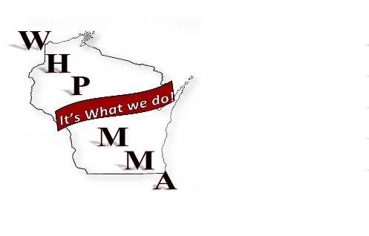
Wisconsin Healthcare Purchasing and Materials Management Association

11/6/2018
WHPMMA Board meeting

On the conference call: Carol Blend, Sean Brennum, Leah Shatusky, Liz Cook, Joe Ford

Agenda:

Approve minutes form October.
- Will post to WHPMMA.org when approved
  - Minutes approved and Posed to Web page

Logo Change
- Approved?
  - Logo Approved
  - Will hold another logo “Contest” in a couple years
- Thank you letter to Marshfield
  - Sean will send a letter to Marshfield thanking them for their submission

Letter from the President
- Carol will be sending a letter asap.
  - Sean will post on WHPMMA.org as well as to be sent out to members.
  - Topics: Who we are as an organization today and where are we going.

Final Approval on location
- Appleton @ Paper Valley
  - Approved
  - 2019 conf. will be held in Appleton at Paper Valley

Confirm Date for 2019+
- Thing discussed
  - 2 day conference
  - 3 days with golf (2 class room days)
    - “3 days is difficult for a lot of staff to get out of work.”
  - 1 day (I do believe this was mentioned)

- Items discussed in relevance to WHPMMA 2019 fall conference
  - Three “full” days is too many for people to get off work (this is if we kept golf)
  - 2 days with an optional “welcome reception” on the first evening
  - When would we do the vendor fair
    - Move it to the Afternoon
    - Include vendors at to the reception on day 2 (day one of classroom)
      - Other topics discussed during this time:
        - How do we get more interest in the vendor fair?
        - Can we do a “big prize” giveaway for vendor fair participation?
          - This is something that is done at ARMM
          - This is something that may have been done in the past at WHPMMA
        - Could we do a bingo type game to get more interest
          - Would be maybe in conjunction with a business card exchange.
        - THIS IS AN ON GOING TOPIC
  - Shortening the conference could be an issue for AHRMM CEU credits
    - What is the requirement for receiving CEU credits
  - FINAL DECISSION WAS MADE TO SET THE DATE FOR SEPT 11-13
    - IF YOU CHOOSE TO COME IN ON THE 11TH THERE WILL BE A WELCOM RECEPTION THAT EVENING.

Golf 2019?
- Turnout continues to drop
  - Vendors outweigh the members
- This is just an added expense
  - Golf
    - Including no shows
  - Meals
    - This includes no shows as meals are preordered and made
- Too difficult to get off work or justify getting off for just golf.
  - This is even more so if you have multiple staff members from one place attending the conference.
- Not everyone likes golf
  - Can we do cornhole?
    - Where would we do it
      - Park near by
      - In the hotel court yard
    - What’s the format?
    - Do we have enough boards?
- No golf in 2020 as we will be moving to spring and higher cost coupled with potential of still having snow on the ground.
- FINAL DECITION WAS TO PASS ON GOLF AND CORNHOLE. THERE WILL BE A RECEPTION BOTH WENDSDAY NIGHT FOR MEMBERS AND THURSDAY FOR MEMBERS AND VENDORS.

Speakers

- James Russell
- Pete Lukszys
  - Small Fee and travel
  - WE HAVE EXTENDED AN OFFER TO PETE
- John Mckeller
  - Small fee
- Costs?
- Karen?
  - UW

- Kyle?
  - UW
- Scott Porterfield
  - Agrace
  - Negotiations
- Girard Senn
- Can we utilize WHPMMA’s collective intelligence to come up with relevant topics and we present them instead of paying multiple speakers?
- Still looking for a good Keynote

Moving the conference to Spring 2020
- Green Bay Kohler
- May of 2020
- APPROVED THIS MOVE

Financials form WHPMMA 2018
- Still have one unpaid vendor
  - “The check was recut and sent last week”

Webinar lunch and learn (Girard Senn)
- Nov. 29th Noon
- Send out a request for questions/invite to the Webinar

